Week 07 Word Press Tasks - Introduction to WooCommerce - Updated 15 Aug-17
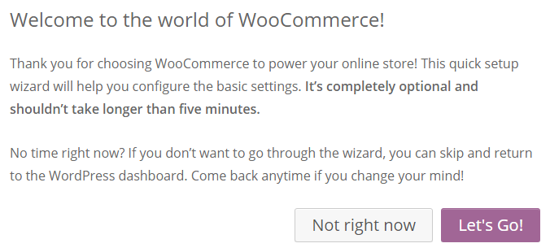
This exercise should be done on your GOHOSTING site eg. http://smith1.it5a.com.au (not on jupiter)
- Install and Activate the plugin WooCommerce. (by Automatic).
- Next select Let's Go for the quick setup wizard, which first creates 4 important new Pages as shown below left.
- Also Choose Australia - Victoria and A$ as currency and then the tax settings shown below. We'll add Shipping later
- Payments for this site could be via PayPal only (the top one is called PayPal Express Checkout), but you do need a PayPal Business account. (This uses PayPal's Checkout page not your WooCommerce Checkout page.)
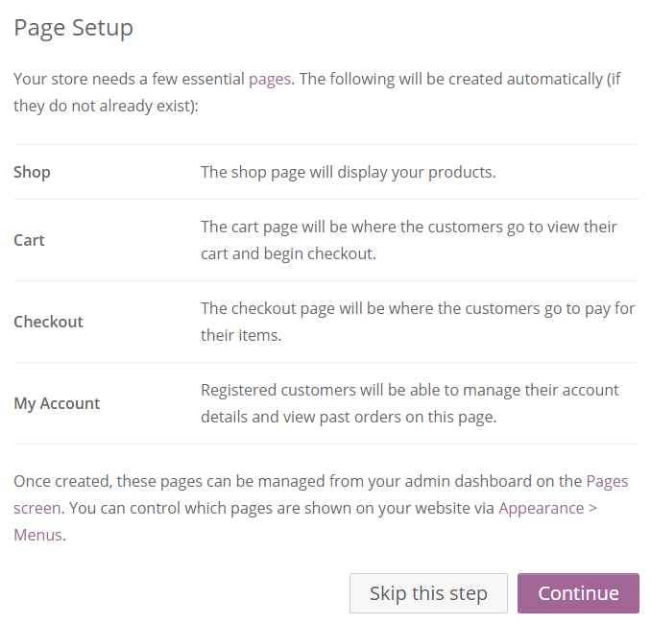
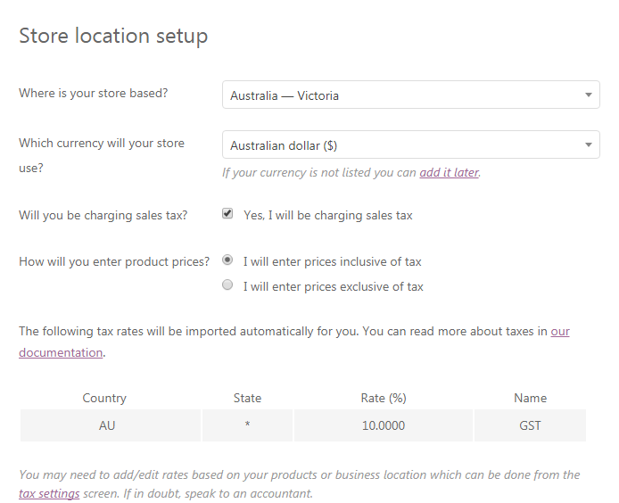
For Stripe you would need an https: site and SSL certificate. (What is this? Google it)

- Let's not install Storefront just now.
- Now you can click on  and look at what is required, but let's not add a new product for the moment. Just choose Return to the WordPress Dashboard.
We will first make some additional WooCommerce Settings which we require.
- For steps 4 and 5 below you may wish to briefly document any key steps in a Word document: What exactly did you do? A couple of Snips or screenshots may be useful.
- Go to WooCommerce Settings, as opposed to WordPress Settings. The following settings are important:
- Make sure that products are for sale in Australia only in A$ (under General settings).
- Do not Enable site-wide store notice text "This is a demo site …" It can obscure the menu and looks very ugly!
- Many of the default settings under Products (and the other tabs) are fine. But uncheck both reviews and ratings
- However under Products on the Display sub-tab you will probably need to change the Product Images to 3 x 4 as follows, as the two images we have are both portrait, not square. The images should be identical in size. Save changes
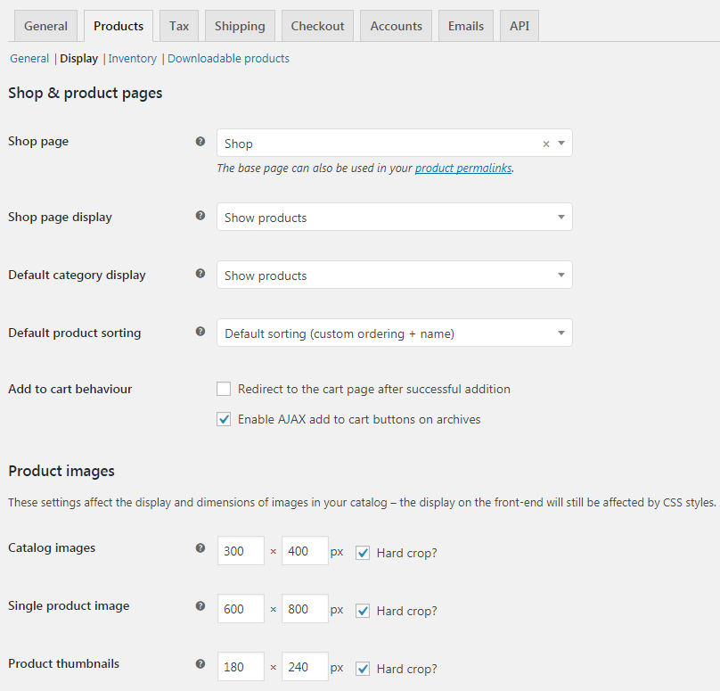
NOTE 1:
Always choose sizes larger than required, not smaller. Why?

NOTE 2:
After changing these settings you may need to regenerate your thumbnails eg. via the plugin Regenerate Thumbnails
- Make sure that both the Display Prices on the Tax tab are set to "Including tax". It is compulsory to do this in Australia.
- On the Shipping tab first Add shipping zone, namely Australia
- Check the Shipping options. What is a Shipping class? Do we need a Shipping class or not?
- To charge $10.00 per order you would simply enter 10.00. To charge $5.00 per item you would enter 5.00 * [qty]
To charge $10.00 per order and $5.00 per item you would enter 10.00 + (5.00 * [qty])
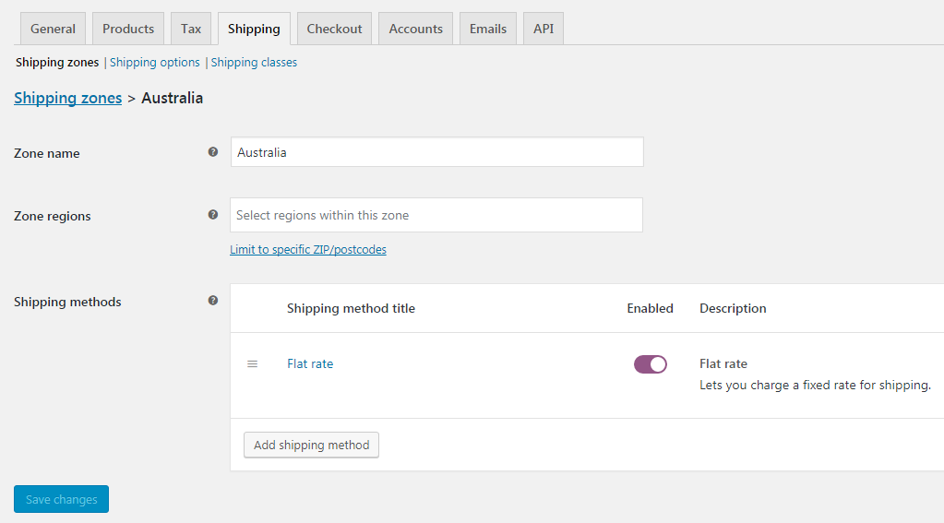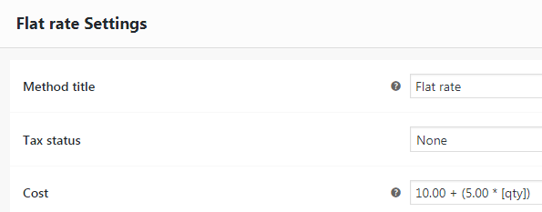
Choose Tax status None as Shipping is already taxed (It includes 10% GST)
- Under Checkout do not Enable coupons but do Enable guest check (What is guest checkout?) Also check that PayPal Express Checkout is Enabled and Save Changes. If not, go to the PayPal tab and Enable PayPal standard
- Accounts can usually be left as is. Click on Emails and View Template to see the emails. Add your RMIT email if req'd.
- Create two or more product pages via Products | Add New
- You will need to add some basic product data, such as a Product name and a Product description (in the top text box) and probably a Product short description (in the bottom text box), which appears next to the image under the price).
- Product variations will also not be required in this case. You can just add a Simple product
- Add any further required Product data such as theSKU (eg. PRO1) (under Inventory) if required, Regular price etc.
- If you add a Sale price, be sure to add the sale period (Schedule) as well eg. from 26 Dec to 31 Dec.
- Also add a Product image (on the right) which will apear on the Shop page. Do not use either of the two Add Media buttons, which place the image elsewhere. Finally click on Publish.
- On Blackboard there are photos of a beach towel and a backpack (from pixabay.com) which you could use.
- Product Categories are not really required in this case. You can omit these if you wish.
Feel free to sell different products using a legal image eg. from http://pixabay.com
- You could create a suitable PDF and use it as "downloadble product", if you have time.
- You should also disable Reviews (Comments) on the two products as follows:
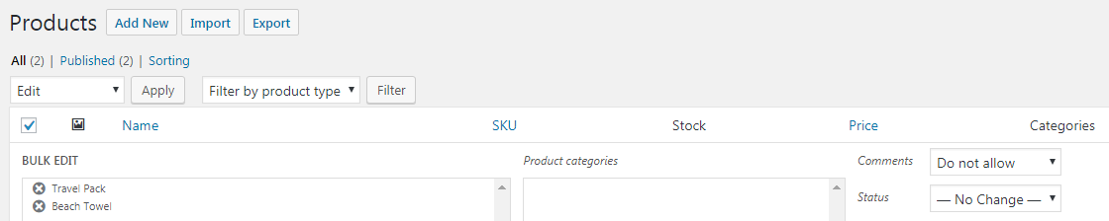
- Place the Shop page at far end right hand end of the menu. Place the following 3 Pages under the Shop Page on your menu. (Go to Appearance | Menus)
- Cart, Checkout and MyAccount (These will therefore be sub-menu pages, as per http://lewis3.dipit.com.au)
- Also change the template for these four Pages to "Full width" or similar and disable comments. This may not work in the Shop pages ie. You may still see a sidebar (removable only via CSS). Make sure you theme is truly "WooCommerce friendly".
You will need to choose an individual theme ASAP:
This video is highly recommended: https://www.youtube.com/watch?v=pAr2GnFrGV4 (from the 2 min mark) It covers 10 great free themes from 2015. This is great also: https://www.sitepoint.com/9-of-the-most-popular-free-wordpress-themes/ You should also Google something like "free WooCommerce themes".
- Your theme will need to be "responsive". Most are, but this should still be checked on both a phone and a tablet.
- Your theme will also need to be "WooCommerce friendly": This can be checked by simply going to a single product page.
- Your theme should also have lots of options available under Customize (or similar) including a "full width" template
Changing the Page Template (via Bulk Edit)
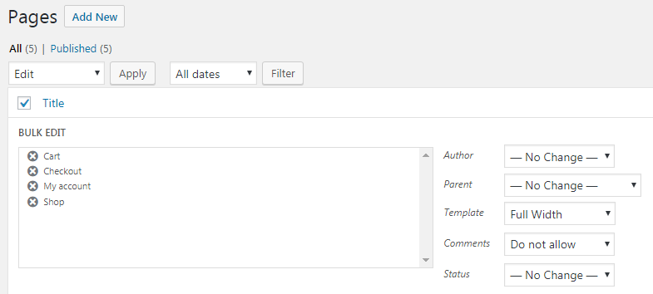
Adding a New Product
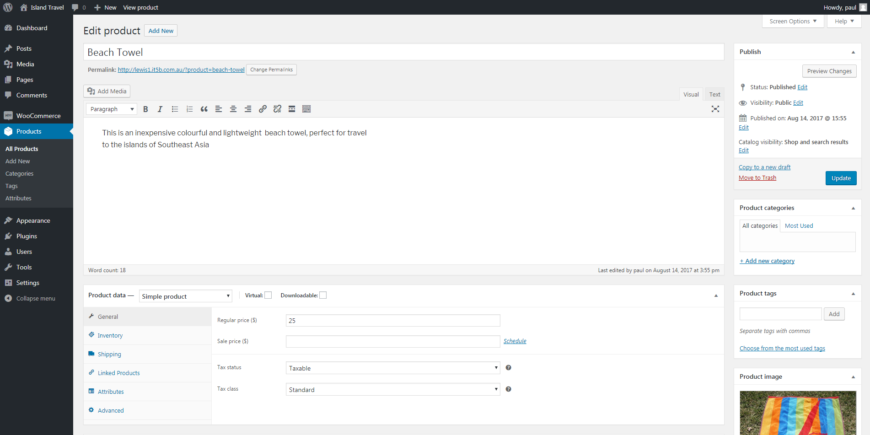

The Shopping Cart
